Fig. S6

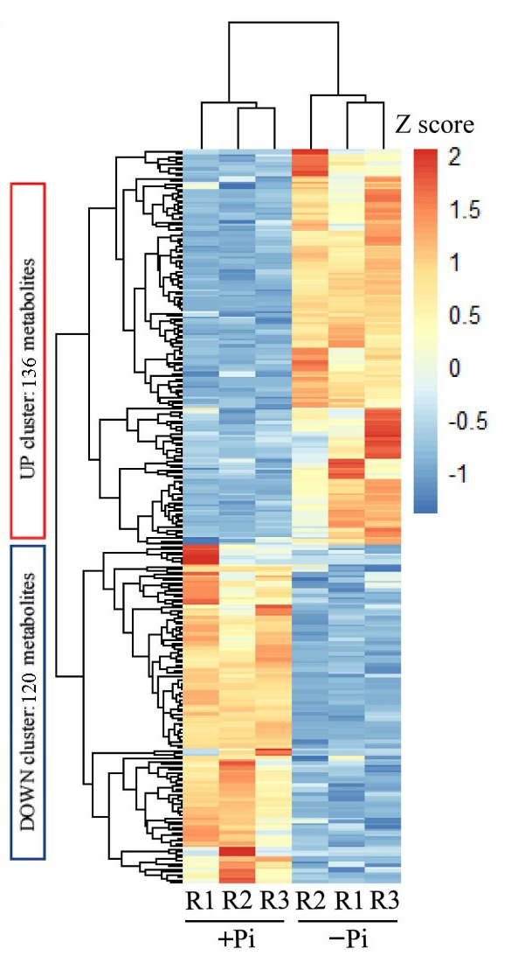
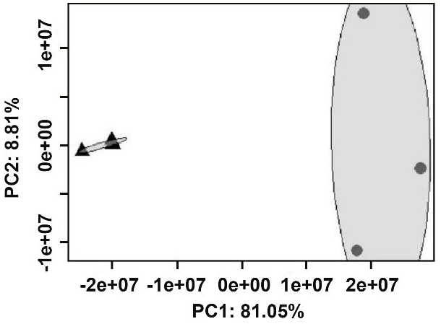
（b）
（a）

Additional file 1: Fig. S6 Analysis of stylo root metabolites under two P treatments. (a) Principal component (PC) scores of metabolic the first two variances in stylo roots (n = 3). Stylo seedlings were grown in +Pi (250 μmol/L KH₂PO₄, triangles) and −Pi (0 μmol/L KH₂PO₄, circles) nutrient solutions for 15 d. The confidence level in the grey confidence circle is 95%. (b) Clustered heatmap of differentially accumulated metabolites (DAMs) in stylo roots at low P stress. Individual metabolites are represented by rows and nutritional status are represented by columns. Heatmap visualization of metabolites is based on standardized transformation (Z score) of metabolite concentrations.

